 | じょうほう |  |  |  |  | よそう | けっか
 | いろ | どうぶつ | たべもの | すきなこと | まほう | よそう | けっか
１ |  |  | 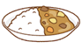 | 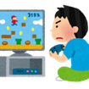 | 
２ |  | 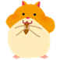 |  | 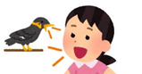  
３ |  | 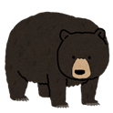   |  |  | 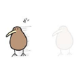
４ |  |  |  |  | 
５ |  |  |  |  | 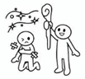
６ |  |  |  |  | 
７ |  | 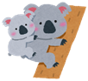 | 
８ |  | 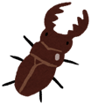 | 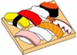
９ |  |  |  | 
１０
１１ |  |  |  | 
１２ |  |  |  | 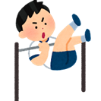
１３ |  | 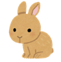 | 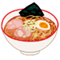
１４ |  |  | 
 | じょうほう |  |  |  |  | よそう | けっか
 | いろ | どうぶつ | たべもの | すきなこと | まほう | よそう | けっか
１５ |  |  |  |  | 
１６ |  | 
１７ |  |  |  | 
１８
１９
２０ |  |  | 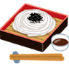 |  |  |  | なまえ
２１ |  |  | 
２２
２３ |  |  |  | 
２４ | 
２５ |  | 
２６
２７ |  |  |  | 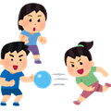
２８

